WEEK 2 TASK

Task: Advanced Data Visualization and Storytelling with Python
Internship: Virtual Data Science with Python Apprentice Intern
Name: Vasundhara Chandra
Dataset: Titanic Passenger Dataset
Tools: Python, Pandas, NumPy, Matplotlib, Seaborn

1. Introduction
Data visualization helps present complex data in a simple and understandable way. In Week 2, the Titanic dataset was analyzed using Python to create advanced visualizations and identify important patterns.
Different charts were used to explore survival based on gender, passenger class, age, fare, family size, and embarkation port.

2. Objective
The main objectives of this task were:
- Create at least 5 advanced visualizations.
- Identify important patterns and trends in the dataset.
- Use visualizations to communicate data insights clearly.
- Practice data storytelling using Python.
- Understand possible business and scientific implications of the findings.

3. Dataset
The Titanic Passenger Dataset was used for this analysis.
It contains information about passengers including:
- Passenger class
- Gender
- Age
- Fare
- Family information
- Survival status
- Embarkation port
The cleaned Titanic dataset from Week 1 was used for this task.

4. Tools and Libraries
The following tools and Python libraries were used:
- Python
- Pandas
- NumPy
- Matplotlib
- Seaborn
- Google Colab / Jupyter Notebook

5. Data Preparation
Before creating the visualizations, the cleaned dataset from Week 1 was used.
Additional features were created to improve the analysis.

FamilySize
FamilySize = SibSp + Parch + 1
This represents the total number of family members travelling together, including the passenger.

TravelAlone
Passengers were categorized into:
- Alone
- With Family
Family size was also grouped into:
- Alone
- Small Family
- Large Family

6. Visualizations and Analysis

6.1 Survival Rate by Passenger Class and Gender
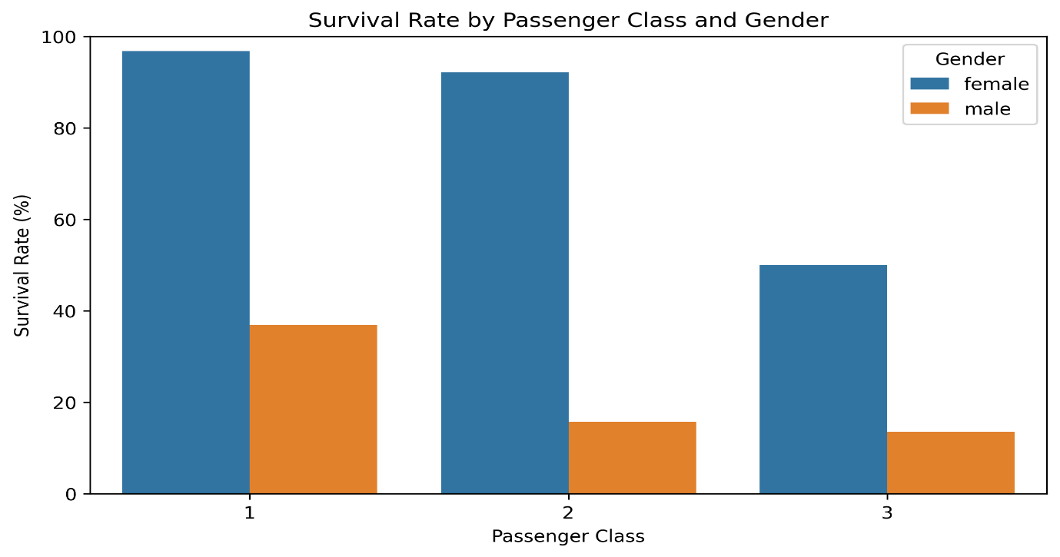
Visualization Type: Grouped Bar Chart

Purpose
This visualization compares survival rates based on passenger class and gender.

Key Insight
Female passengers generally had higher survival rates than male passengers. Passenger class also showed a clear relationship with survival.

Why this visualization was used
A grouped bar chart makes it easy to compare different passenger groups side by side.

6.2 Age Distribution by Survival Status
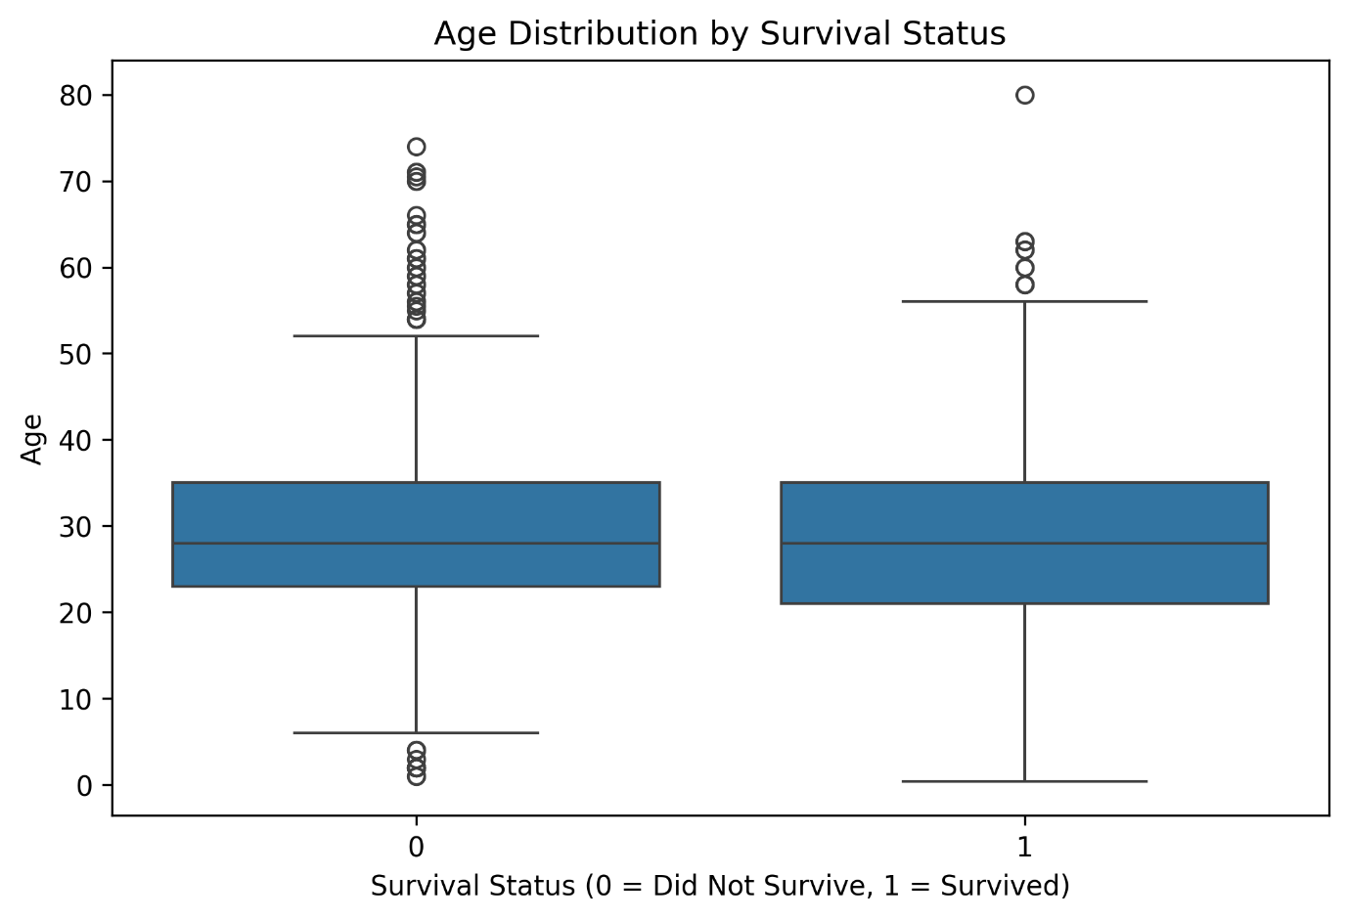
Visualization Type: Box Plot

Purpose
This visualization compares the age distribution of passengers who survived and those who did not survive.

Key Insight
The age distributions of the two survival groups showed some differences, although age alone does not explain survival.

Why this visualization was used
A box plot clearly shows the median, spread, and variation of age values.

6.3 Fare and Age by Survival and Passenger Class
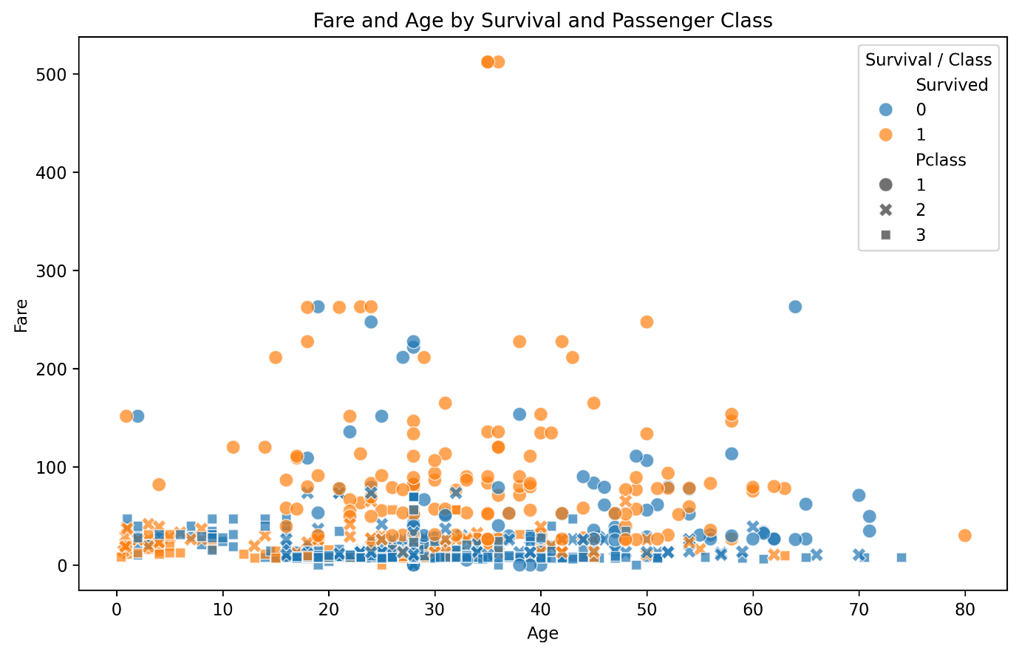
Visualization Type: Scatter Plot

Purpose
This visualization examines the relationship between passenger age and fare while also considering survival and passenger class.

Key Insight
Passengers from different classes showed noticeable differences in fare values. Higher fares were generally associated with higher passenger classes.

Why this visualization was used
A scatter plot helps identify relationships, patterns, and clusters between numerical variables.

6.4 Survival Rate by Family Size
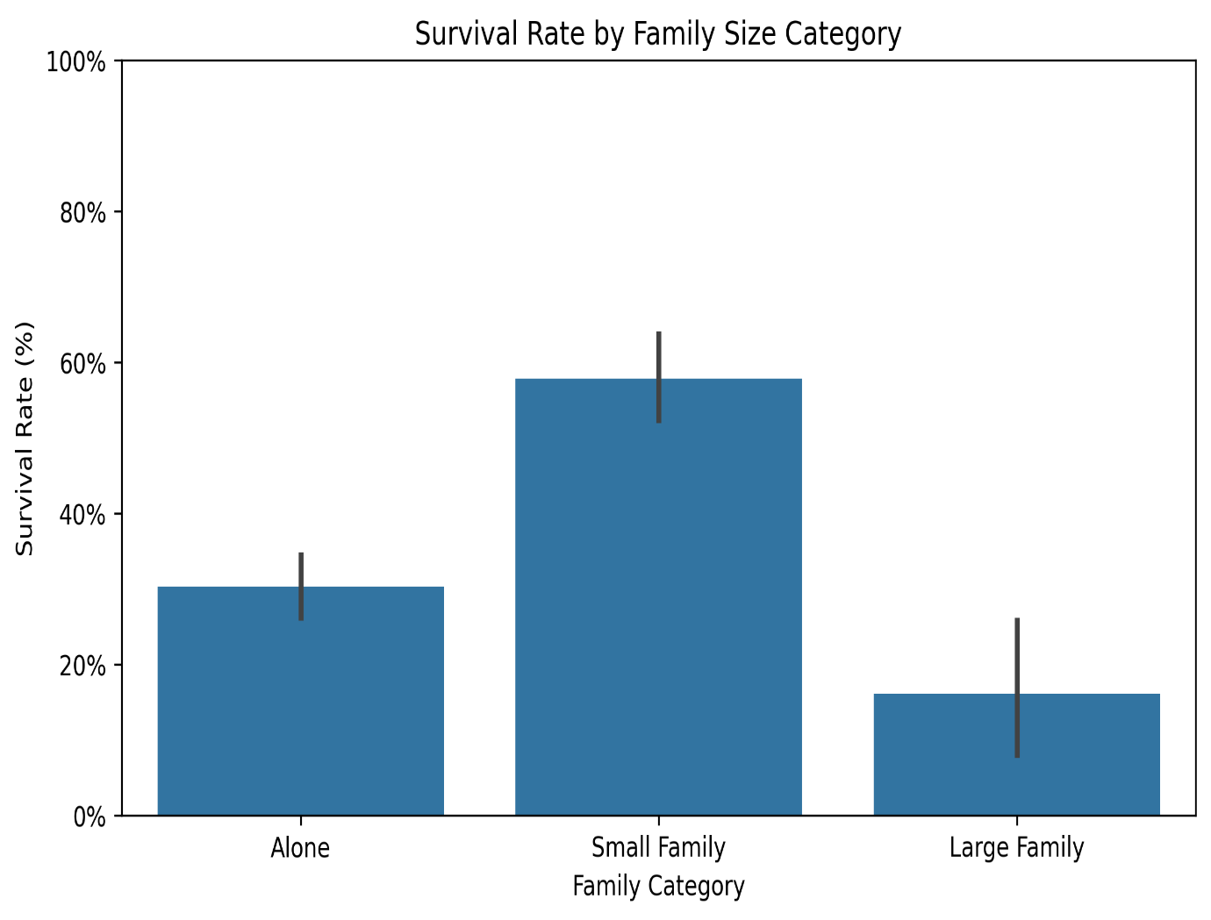
Visualization Type: Bar Chart

Purpose
This visualization compares survival rates between passengers travelling alone and passengers travelling with family.

Key Insight
Passengers travelling with different family sizes showed different survival patterns.

Why this visualization was used
A bar chart makes it easy to compare survival rates across family-size groups.

6.5 Survival Rate by Port of Embarkation
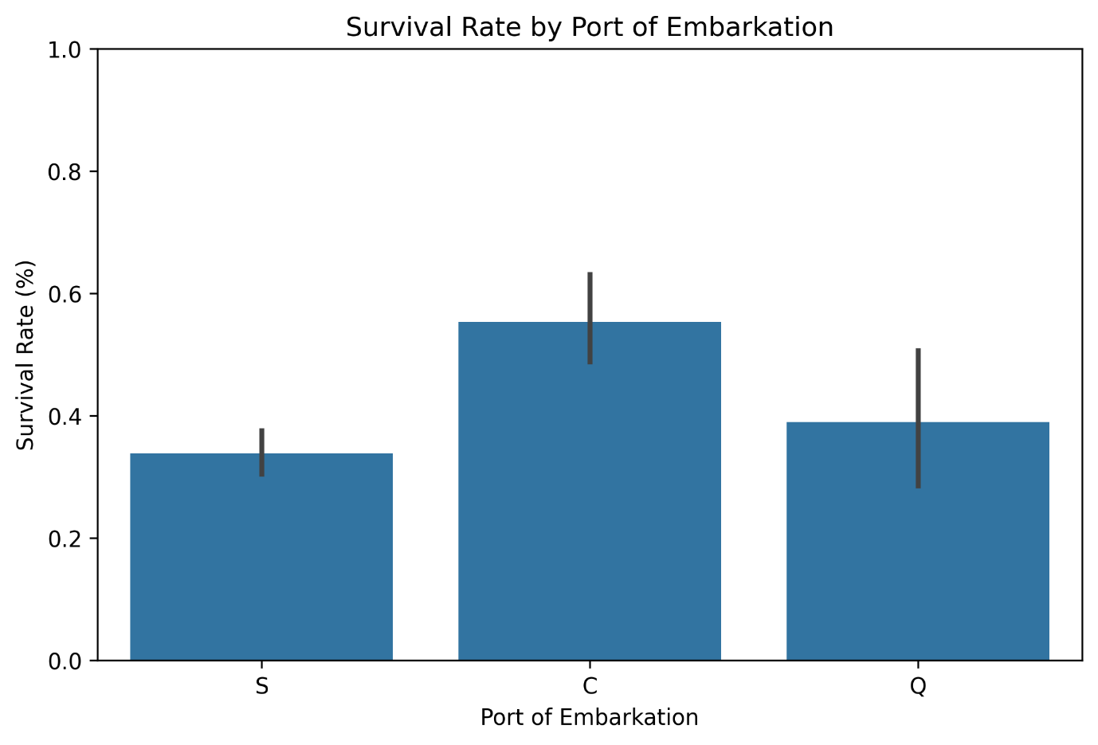
Visualization Type: Bar Chart

Purpose
This visualization compares the survival rates of passengers based on their port of embarkation.

Key Insight
Survival rates varied between the three embarkation ports: Cherbourg, Queenstown, and Southampton.

Why this visualization was used
A bar chart provides a simple comparison between categorical groups.

7. Data Storytelling
The visualizations create a simple story about the factors associated with passenger survival.
The analysis starts with gender and passenger class, which show noticeable differences in survival. It then explores age and fare, followed by the effect of family size and embarkation port.
Together, the visualizations show that survival was influenced by multiple passenger characteristics rather than a single factor.

8. Key Insights
The main insights from the analysis are:
- Female passengers had higher survival rates than male passengers.
- Passenger class was strongly associated with survival.
- Age showed differences between survival groups.
- Fare values varied significantly between passengers.
- Family size showed different survival patterns.
- Survival rates varied across embarkation ports.
- Multiple factors should be considered when analyzing survival.

9. Business and Scientific Implications
The visualization techniques used in this project can also be applied to real-world datasets.
In business, similar visualizations can be used to analyze customer behavior, sales, risk, and performance.
In scientific analysis, visualizations can help identify patterns and relationships that can be studied further using statistical analysis or machine learning.
The findings in this project show associations between variables and survival, but they do not prove direct causation.

10. Conclusion
Week 2 provided practical experience in creating advanced visualizations and communicating insights through data storytelling.
Using the Titanic dataset, five different visualizations were created to explore survival patterns based on gender, passenger class, age, fare, family size, and embarkation port.
The task improved understanding of how appropriate visualizations can make data easier to understand and communicate.

11. GitHub Project
GitHub Repository:
https://github.com/vashuchandra08-tech/week-1-titanic-eda

